**Campeonato or ”Soccer Tournament”**

This project was developed in C# Windows forms App (.NET Framework). The database used was Microsoft SQL Server Management Studio. The software “Campeonato” basically was developed to organize soccer tournaments.

**Database Diagram**

Jogador = Player Campeonato = Tournament

Equipe = Team Estadio = Stadium/Field

Sumula = Records of the match Organizacao_Campeonato = Tournament Organization

Jogo = Game

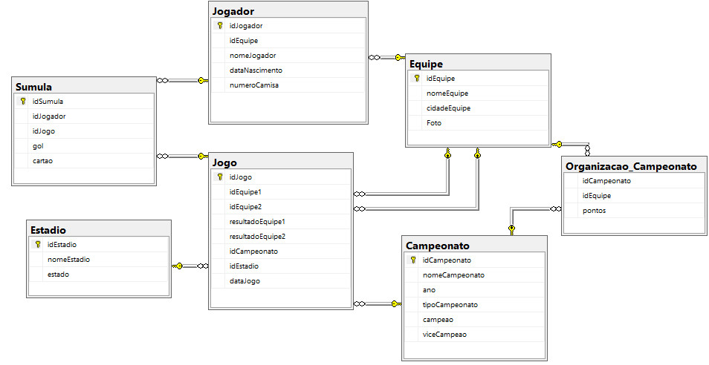

**Home Page**

Left side buttons are for data registration such as to add new players, edit a team, or delete a stadium from the database. Right side buttons are for the tournament creation and organization.

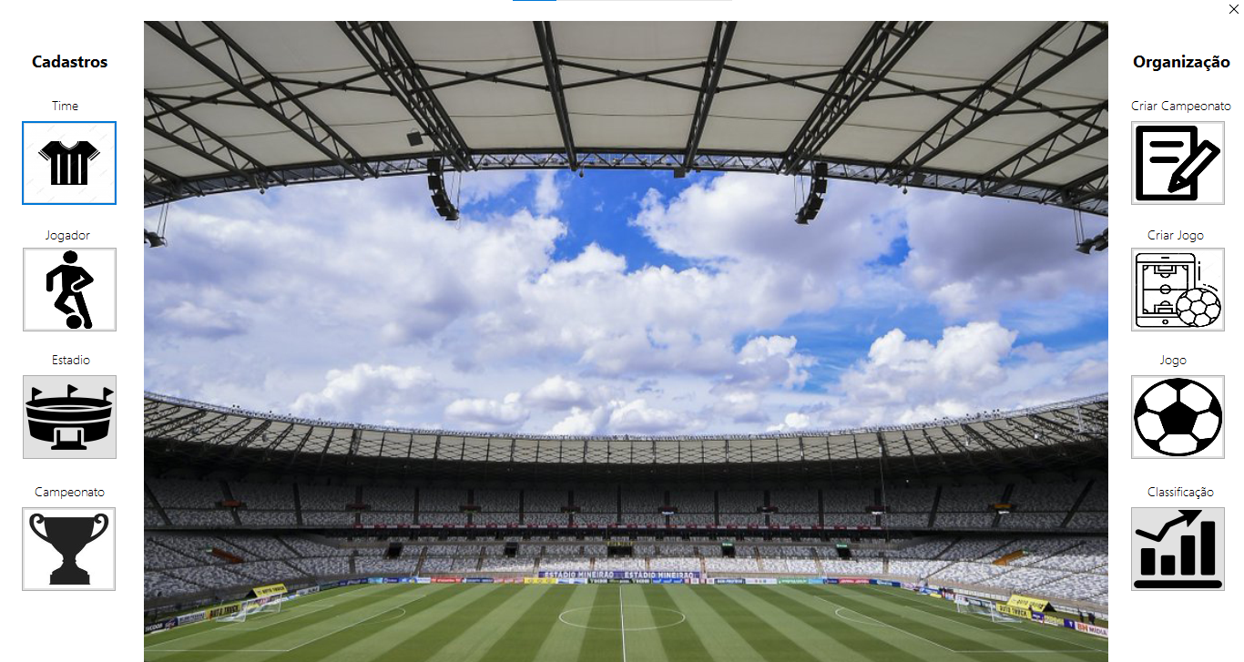

**Team**

Here a new team can be added to the database as well as deleted and updated. Required fields are name of the Team, City and Logo. Also, it is possible to check all team already in the database and filter by the team’s name.

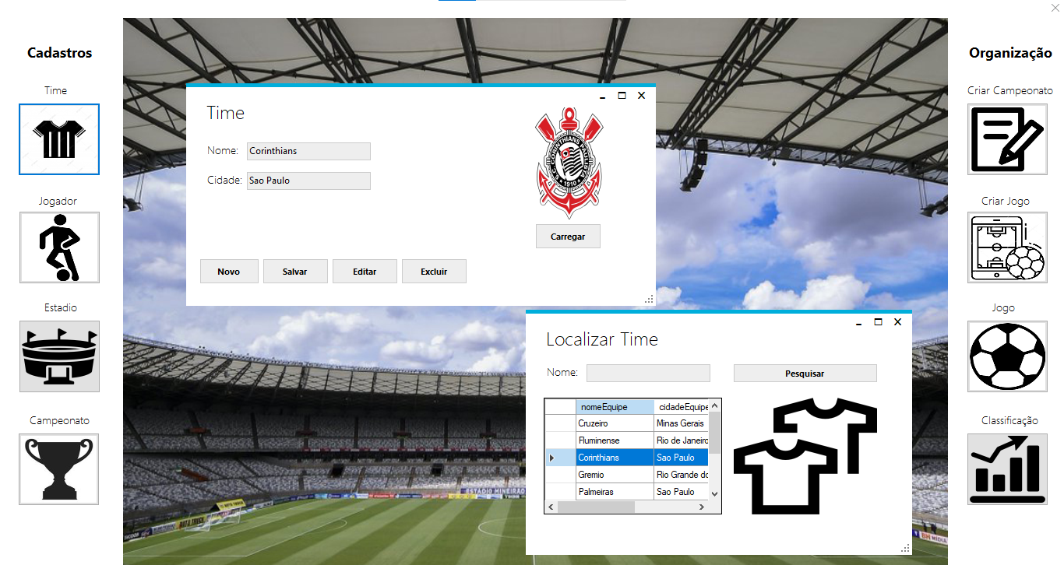

**Player**

This form works as the previous one, but for players. Each player must be linked to a team previously added to the database.

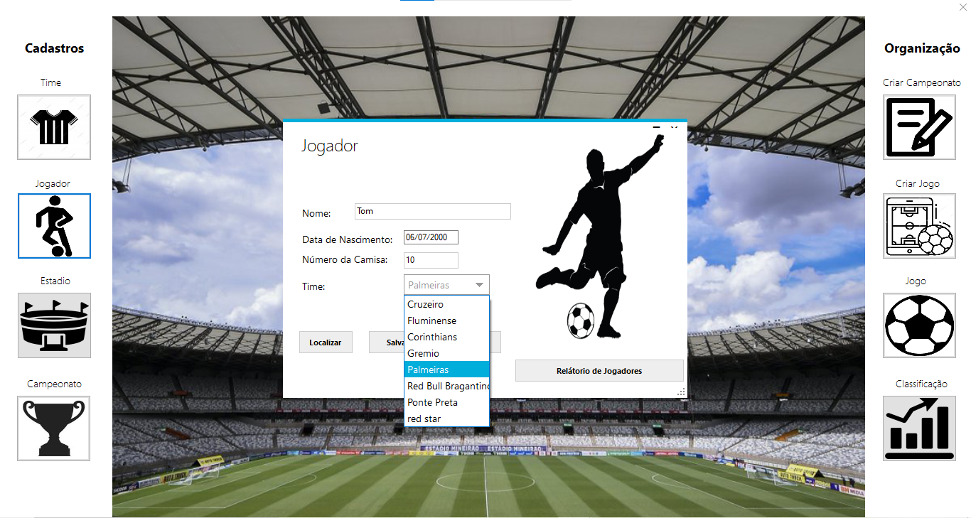

The “Relatorio de Jogadores” button lists all players on their respective teams.

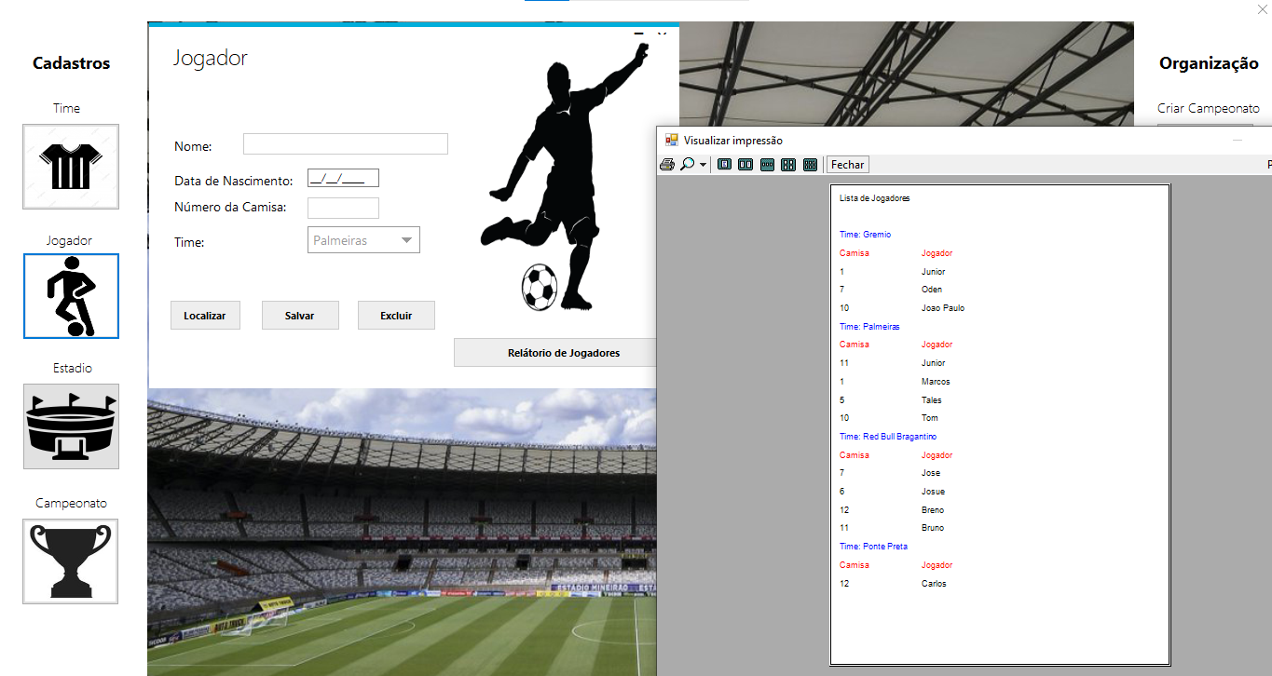

**Stadium and Tournament**

It works just like the players and teams’ forms. It is possible to create a new, update an existing, and delete a stadium or a tournament.

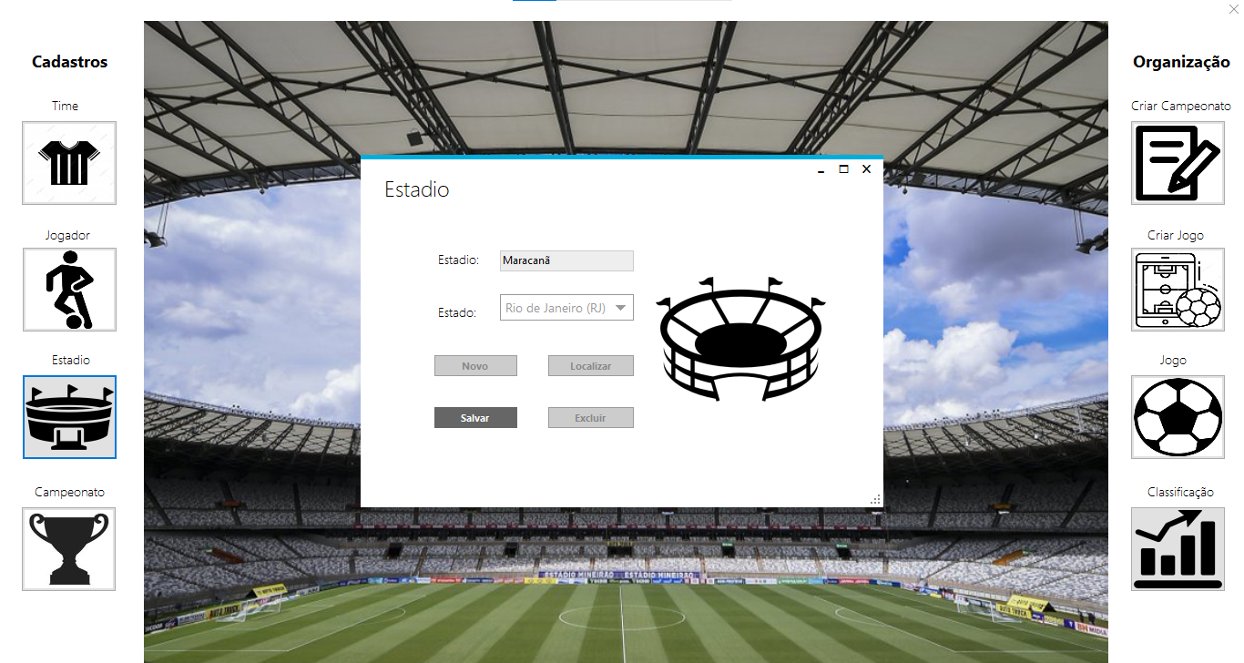

**Adding teams to a new tournament**

Choose a tournament previously registered. Select all teams that are going to participate in the tournament, after selecting each team press the button “Adicionar”. Press the button “Finalizar” to finish the process of adding teams.

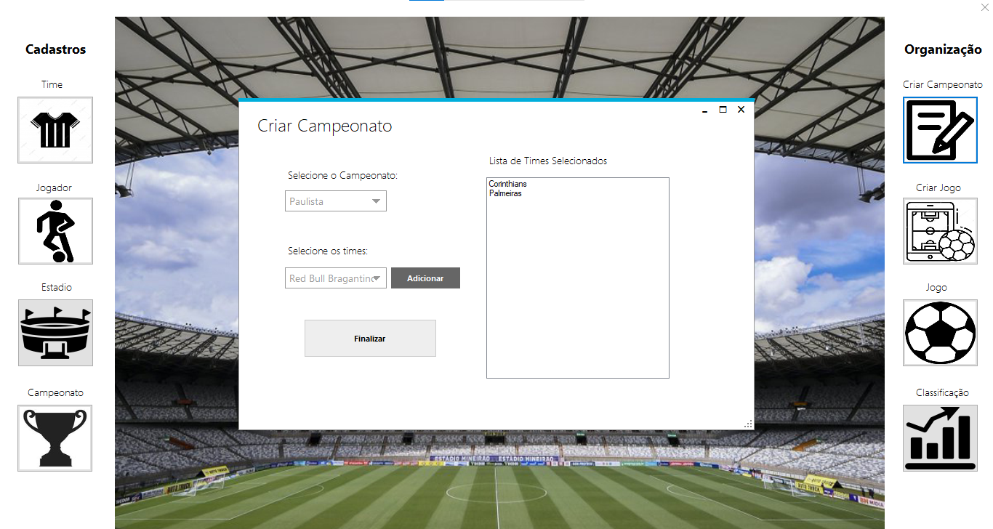

**Creating Game**

Select the tournament, then all teams that are playing in this tournament are going to be available to be chosen. Select one of the teams to play at home and another one to play away. Select the stadium and pick a date for the game.

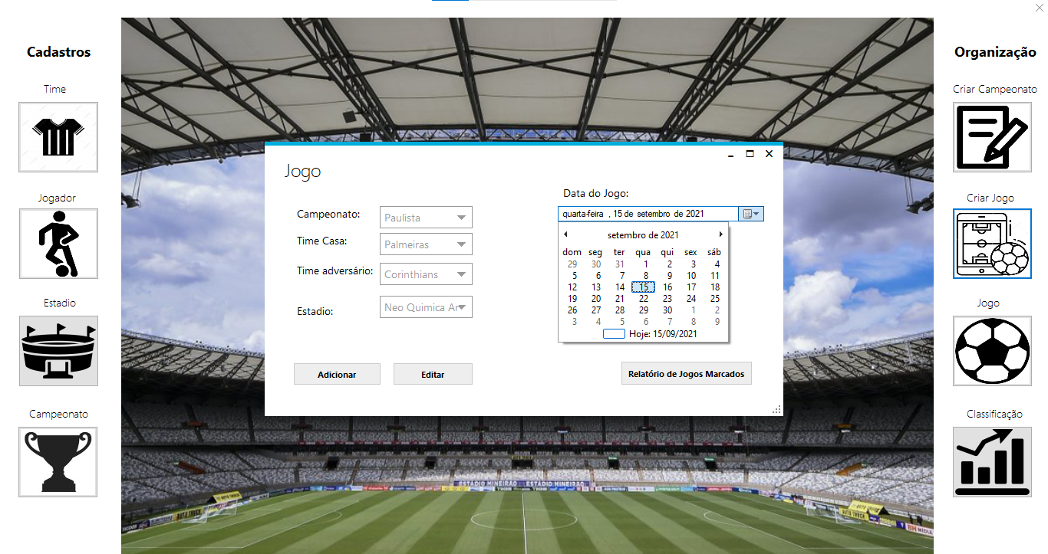

The “Relatorio de Jogos Marcados” button reports all games divided by tournament.

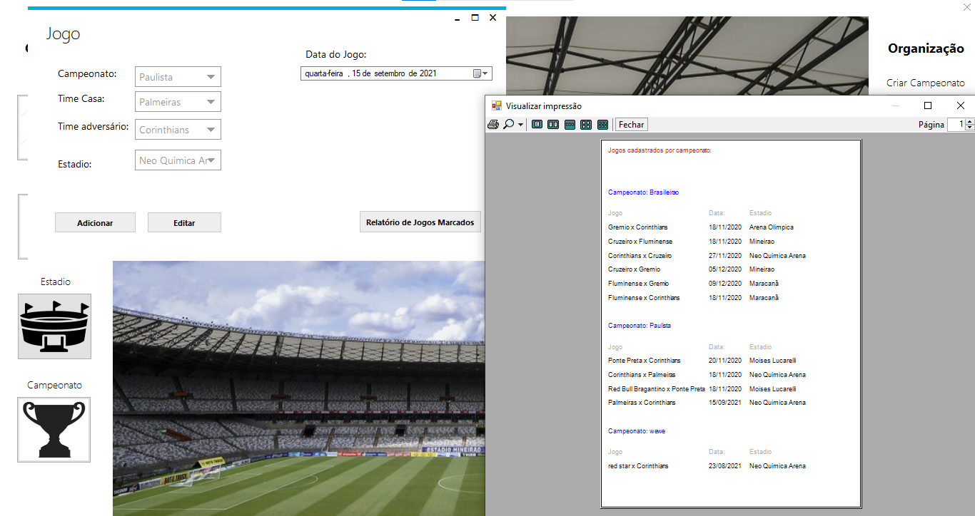

**Game**

Choose a tournament and all games registered for that tournament (games that have not happened yet) are going to be available. Set the time and press “Iniciar Jogo” to start the game.

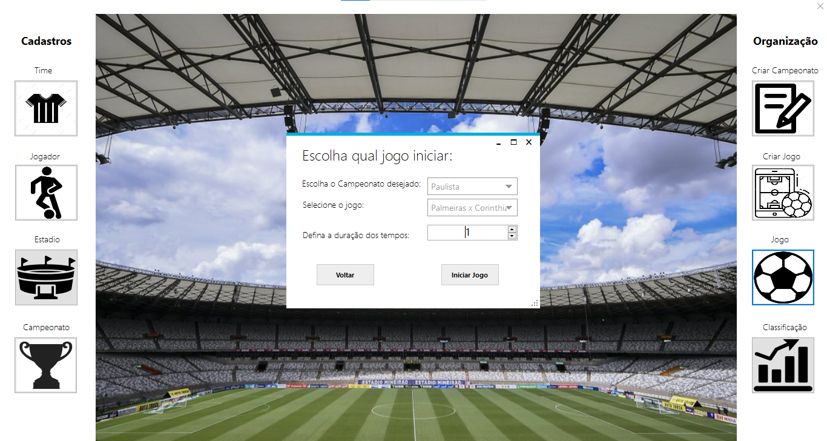

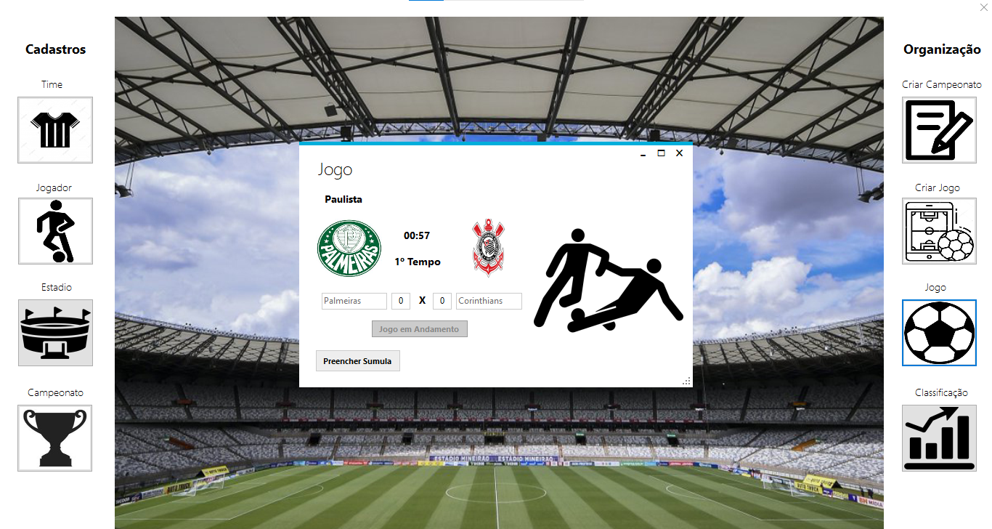

When someone scores press the button “Preecher Sumula” to report the goal.

Select the team and the player who scored the goal and save the information.

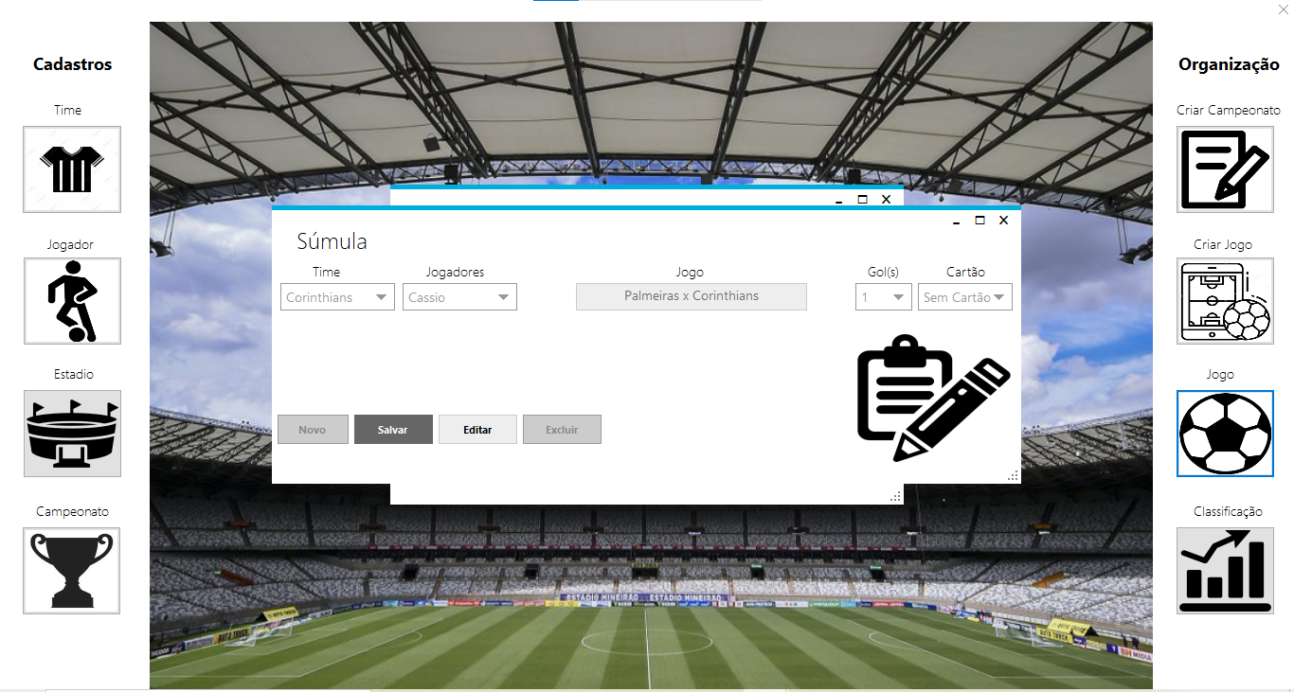

The score automatically updates

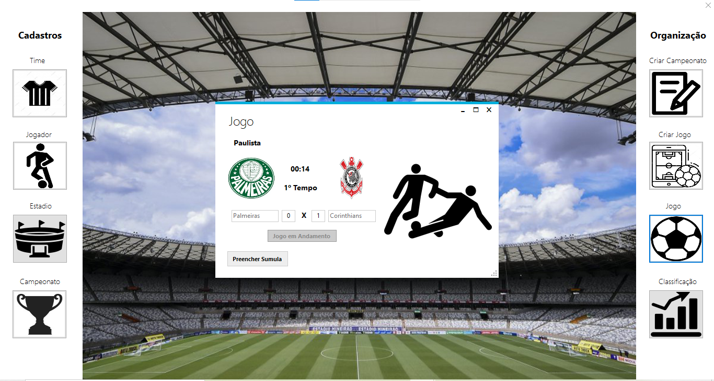

**Standings**

After the game is complete, the score will be visible in the “classificação” button. Also the standings are automatically updated after every game. The winner gets 3 points, loser 0, and if it is a tie each team gets 1 point.

